Minstead 4th to 6th March 2019

Our walk in the Wild Woods. We met donkeys, saw wild ponies and experienced a variety of habitats: deciduous woodland, heath, coniferous woodland, bog land and plenty of fords, streams and huge puddles.
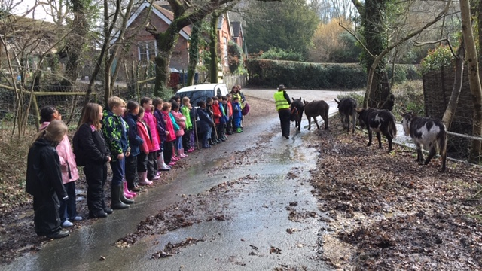
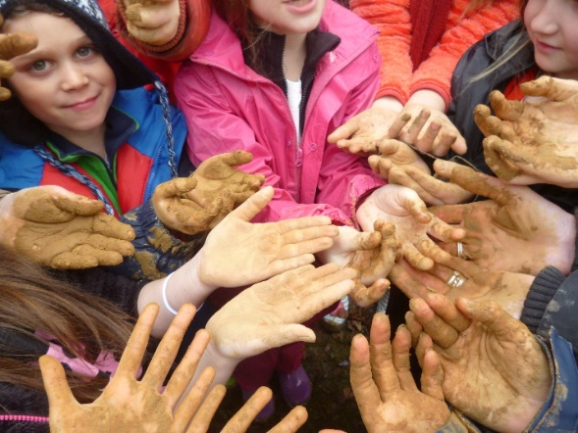
Finding the clay and preparing it to make clay pots is a messy business.
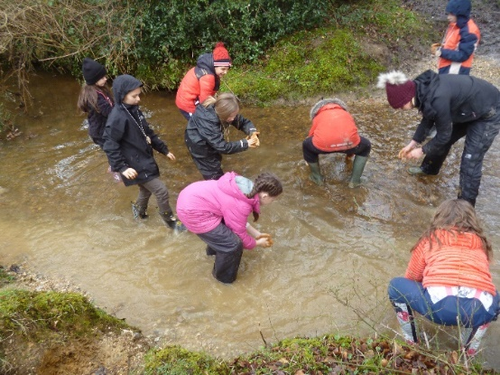

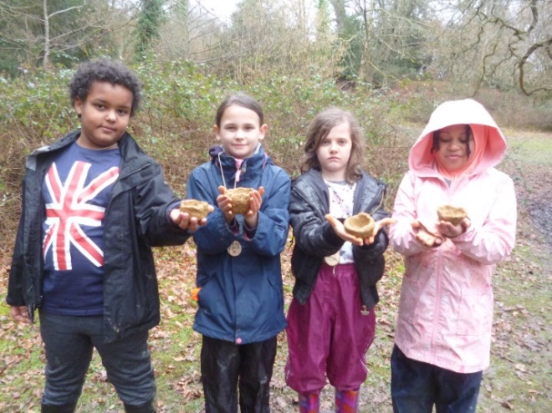

Whilst some of us were getting messy and creative with mud, the rest of us were learning about the relationship between man and animals and how farming affects both us and the creatures farmers care for.
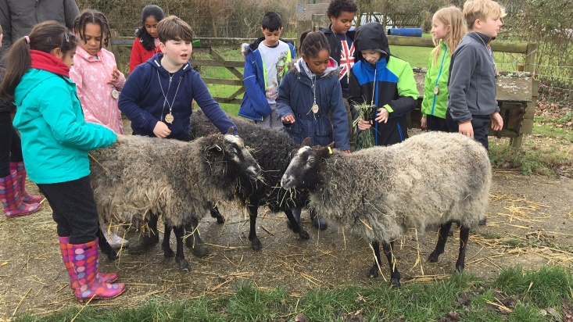

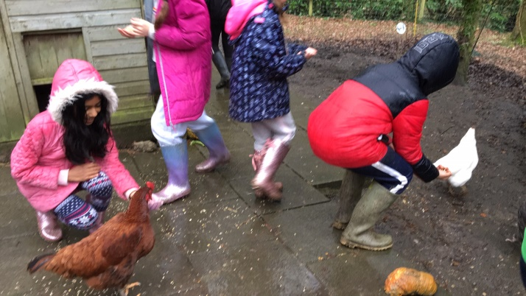

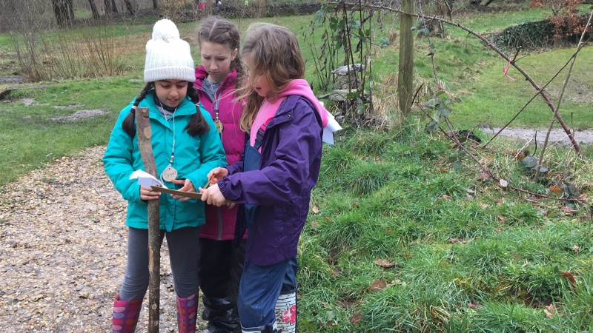
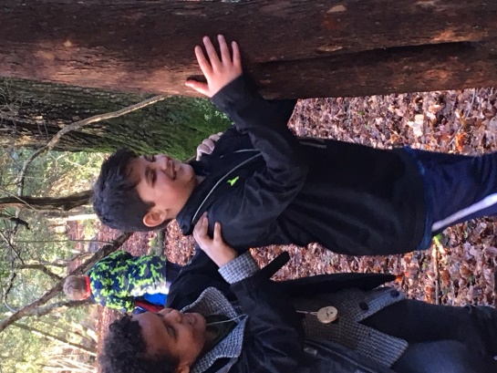
We worked hard and played hard together. It was great being a part of such a positive trip.

