Winklebury Infant School
ONLINE OPEN EVENTS
For parents of children who are due to start infant school in September 2021

Due to Covid-19 restrictions under HCC guidelines we are currently not allowed to conduct visits for prospective parents to the school.
We are in the process of making an introductory video that will be available to watch on our website after half term.
In addition from the 2nd November we will have some dates for live Microsoft Teams meeting with Mrs Mathlin, the Headteacher, who will provide you with information about the school and answer any questions you may have.
We are sorry that we cannot welcome you and your family in person as we normally would but we hope through the video and talking to us you will get a feel as to the ethos of school.
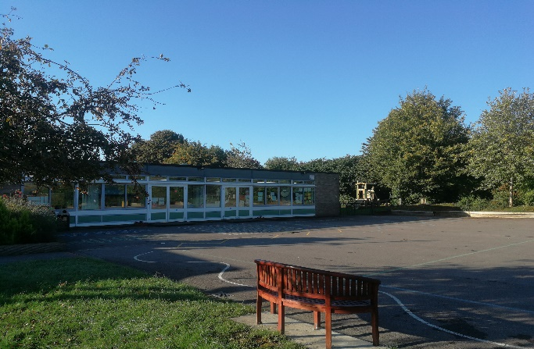
We look forward to welcoming you to Winklebury Infant School.
For more information please contact the Federation Admin Office
on 01256 323244 or email adminoffice@winklebury-inf.hants.sch.uk

